What are environment variables?
An environment is the base on which your code runs.
When your code breaks, you want to fix your code but leave your environment untouched.

For e.g. In your session, your environment already has loads of python packages preloaded
Hence, all you need to do is just import the required package and build your code.

Now, when you have sensitive information like auth keys, tokens etc., you need to hide all of this information when you upload your code publicly. One way to do it is to embed the information into your environment.

These are called environment variables.

In the Anaconda terminal, use the ‘set’ keyword to set the environment variables:

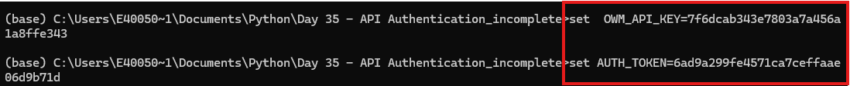

Similarly, use the ‘set’ command to check the list of environment variables:
